MAGNETISM AND MATTER

Magnetic Moment of a Current-Carrying Loop
• The Concept: A current-carrying loop acts as a magnetic dipole, similar to how two equal and opposite charges form an electric dipole.
• Fundamental Formula: The magnetic moment (M⃗) of a loop is defined as:
M⃗ = NIA⃗
- N: Number of turns in the loop.
- I: Current flowing through the loop.
- A⃗: Area vector of the loop.

• Physical Meaning: The loop creates a magnetic field where field lines exit from one face (North Pole) and enter through the other (South Pole).
• Units: The SI unit is Ampere-meter² (A·m²).

• Direction Rule (Right-Hand Thumb Rule):
Curl the fingers of your right hand in the direction of the current.
The stretched thumb points in the direction of the Magnetic Moment (M⃗) and identifies the North Pole.
• Loop Faces:
- If current appears Clockwise, that face is the South Pole.
- If current appears Anti-clockwise, that face is the North Pole.

• Observation: For a fixed length of wire, the Circular Loop provides the maximum magnetic moment because it encloses the maximum area.

Advanced Vector Addition (Loops in Different Planes)
A. The Folding Concept
When a loop is not in a single plane (e.g., a square loop folded at 90°), the net magnetic moment is the vector sum of the moments of the individual planar parts.
• Formula: M⃗_net = M⃗₁ + M⃗₂.
• Resultant Magnitude: If two equal parts are at 90°, M_net = √(M₁² + M₂²) = M√2.

B. The +I, -I Trick (JEE Advanced Insight)
To solve complex or "broken" loops, you can conceptually add two equal and opposite currents (+I and -I) along a shared edge to create two closed loops.
• Adding these currents does not change the physical reality (net current = 0) but allows you to treat the shape as two independent dipoles whose moments can be added vectorially.
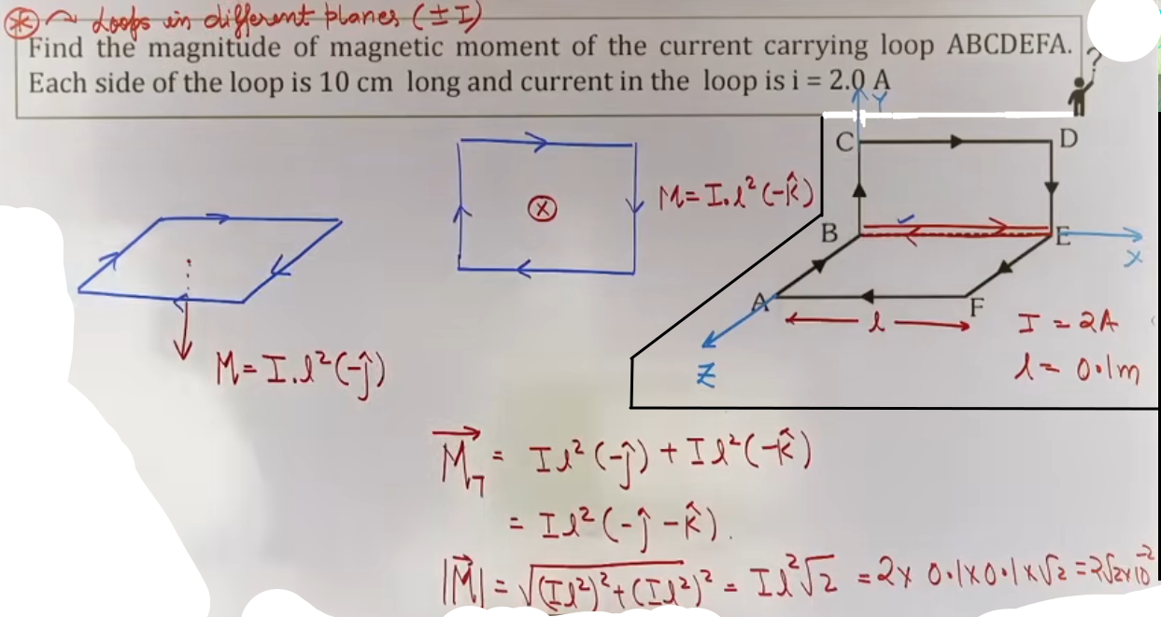

High-Yield Revision Sheet
• Must Remember Formula: M⃗ = NIA.
• Direction: Thumb of right hand (current in fingers).
• Max Area: Circle > Hexagon > Square > Triangle (for same perimeter).
• Vector Sum: For loops at angle θ, M_net = √(M₁² + M₂² + 2M₁M₂cosθ).
• Closed Polygons: For a current flowing through a closed 3D skeletal structure, the net magnetic moment is the vector sum of the moments of its faces.

--------------------------------------------------------------------------------

DIPOLES IN EXTERNAL FIELDS

These notes cover the behavior of magnetic dipoles in external magnetic fields, including torque, energy, and equilibrium states, based on the specified lecture material.

• The Concept: When a magnetic dipole (a current loop or a bar magnet) is placed in an external magnetic field (B⃗), it interacts with that field.

• Net Force (F_net):
- In a uniform magnetic field, the net force on a dipole is always zero (F_net = 0).
- In a non-uniform field, the net force is not zero (F_net ≠ 0), leading to translatory motion in addition to rotation.

• Torque (τ): Although the net force is zero in a uniform field, the forces acting on different parts of the dipole create a "turning effect" or torque, which attempts to align the magnetic moment with the field.

Mathematical Analysis of Torque
• Vector Formula: τ⃗ = M⃗ × B⃗.
• Magnitude: τ = MB sin θ.
• θ is the angle between the Magnetic Moment (M⃗) and the Magnetic Field (B⃗).

• Special Cases for Torque:
- Maximum Torque: Occurs when θ=90°(perpendicular). τ_max = MB.
- Minimum Torque: Occurs when θ=0° or 180°(parallel or anti-parallel). τ_min = 0

Work Done and Potential Energy
• Work Done in Rotation (W): The work required by an external agent to rotate a dipole from an initial angle θ₁ to a final angle θ₂ is:
W = MB(cos θ₁ - cos θ₂).

# Work done = change in K.E. = -change in P.E.

• Potential Energy (U):
- Formula: U = -M⃗·B⃗ = -MB cos θ.
• Physical Significance: It represents the energy stored in the dipole due to its orientation in the field.

Equilibrium States
Equilibrium occurs when the net torque is zero (τ = 0), which happens at θ = 0° and θ = 180°.

State | Angle (θ) | Potential Energy (U) | Stability | Description
Stable Equilibrium | 0° | -MB (Minimum) | Stable | If slightly displaced, the dipole returns to its original position.
Unstable Equilibrium | 180° | +MB (Maximum) | Unstable | If slightly displaced, the dipole moves further away from this position.
[ Teacher's Insight: Think of a bowl. A ball at the bottom is in stable equilibrium (minimum energy); a ball balanced on top of an inverted bowl is in unstable equilibrium (maximum energy). ]

Reshaping Loops
This refers to changing the geometry of a wire of fixed length L while keeping the current I constant.
• Square to Circle Transition:
- Square Loop: Side a = L/4 → Area A = L²/16. M_square = I(L²/16).
- Circular Loop: Circumference 2πR = L → R = L/2π → Area A = π(L/2π)² = L²/4π. M_circle = I(L²/4π).
• Key Comparison: The circular loop has a higher magnetic moment than the square loop for the same perimeter. The ratio is M_circle / M_square = 4/π.

Concept Connections: Electrostatics Analogy
+----------------------------+-----------------------------+
| Electrostatics | Magnetism |
+----------------------------+-----------------------------+
| Electric Dipole Moment (p⃗) | Magnetic Dipole Moment (M⃗) |
| Electric Field (E⃗) | Magnetic Field (B⃗) |
| Torque τ⃗ = p⃗ × E⃗ | Torque τ⃗ = M⃗ × B⃗ |
| Energy U = -p⃗·E⃗ | Energy U = -M⃗·B⃗ |
+----------------------------+-----------------------------+

High-Yield Revision Sheet
Must Remember Formulas:
• τ⃗ = M⃗ × B⃗ (Torque).
• U = -MB cos θ (Potential Energy).
• W = MB(cos θ₁ - cos θ₂) (Work).

• Stable vs. Unstable:
• Stable: θ = 0°, U is min, τ = 0.
• Unstable: θ = 180°, U is max, τ = 0.

[ JEE Advanced Insight: For very small angles θ, the torque τ = MB sin θ ≈ MBθ acts as a restoring torque, leading to Simple Harmonic Motion (SHM) with Time Period T = 2π √(I / MB). ]

--------------------------------------------------------------------------------

PROPERTIES OF BAR MAGNETS

Core Theory and Basic Characteristics
• Definition of Poles: A bar magnet consists of two regions called poles where the magnetic strength is concentrated: the North Pole(+m) and the South Pole(-m)
• Pole Strength (m): This is a scalar quantity representing the strength of a magnetic pole, analogous to electric charge (q). It is directly proportionoal to the area of cross-section, m∝A. S.I. unit A-m.
• Magnetic Monopoles: Unlike electric charges, magnetic monopoles do not exist; if you break a magnet, each piece will still have both a North and a South pole.
• Gauss's Law for Magnetism: The total magnetic flux through any closed surface is always zero (∮ B⃗ · dA⃗ = 0), confirming that magnetic field lines form continuous closed loops.
• Effective vs. Geometric Length: The magnetic poles are located slightly inside the ends of the magnet. The "Magnetic Length" (L) used in calculations is the distance between these two poles, which is roughly 0.84 times the "Geometric Length".
• Neutral Point: In a bar magnet, the attractive power is zero at the center; this is called the neutral point.

Magnetic Moment of Bar Magnets
• Definition: The magnetic dipole moment (M⃗) of a bar magnet is a vector quantity that measures its tendency to align with a magnetic field. It is an axial vector.
• Formula: M⃗ = m · L⃗
• m = Pole strength.
• L = Magnetic length (separation between poles).

• Direction: By convention, the direction of M⃗ is from the South Pole to the North Pole.

• Units: The SI unit is Ampere-meter² (A·m²).

Intuition and Conceptual Understanding
• The "Why" of Magnetism: Magnetism in a bar magnet originates at the atomic level from the orbital motion and spin of electrons, which act as tiny current loops.
• Atomic Alignment: In a bar magnet, these atomic dipoles are aligned in the same direction, creating a macroscopic magnetic effect.
• Breaking the Magnet: When you cut a magnet, you are not separating "North" from "South" but rather creating new boundaries for the existing atomic dipoles, which is why a new North and South pole appear at the break point.

Cutting and Bending Magnets (High-Yield for JEE)
A. Cutting a Bar Magnet
Cutting Method | Change in Pole Strength (m) | Change in Length (L) | New Magnetic Moment (M')
Transverse (Perpendicular to length) | No change (Area is same) | L' = L/n | M' = m(L/n) = M/n
Longitudinal (Parallel to length) | m' = m/n (Area is divided) | No change | M' = (m/n)L = M/n
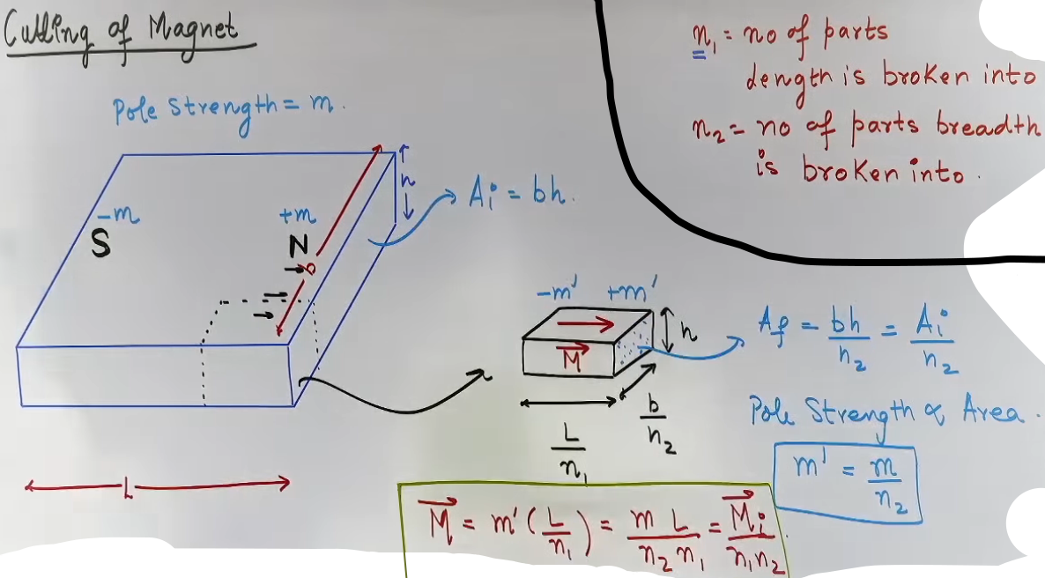
B. Bending a Magnetic Wire
When a thin magnetic wire of length L and moment M is bent, the pole strength m remains constant, but the displacement between poles changes.
+--------------------+----------------------+--------------------------+
| New Shape | Displacement (L_new) | New Magnetic Moment (M') |
+--------------------+----------------------+--------------------------+
| L-Shape (90° bend) | L/√2 | M/√2 |
| Semicircle | 2R = 2(L/π) | 2M/π |
| Full Circle | 0 (Poles meet) | 0 |
+--------------------+----------------------+--------------------------+
Analogy with Electrostatics
JEE problems often allow you to solve magnetism questions by substituting values into known electrostatic formulas.
+------------------+----------------+-------------------+
| Property | Electrostatics | Magnetism |
+------------------+----------------+-------------------+
| Field Constant | k = 1/4πε₀ | μ₀/4π |
| Source | Charge (q) | Pole Strength (m) |
| Dipole Moment | p = q · L | M = m · L |
| Axial Field | E = 2kp/r³ | B = μ₀/4π × 2M/r³ |
| Equatorial Field | E = kp/r³ | B = μ₀/4π × M/r³ |
| Torque | τ⃗ = p⃗ × E⃗ | τ⃗ = M⃗ × B⃗ |
+------------------+----------------+-------------------+
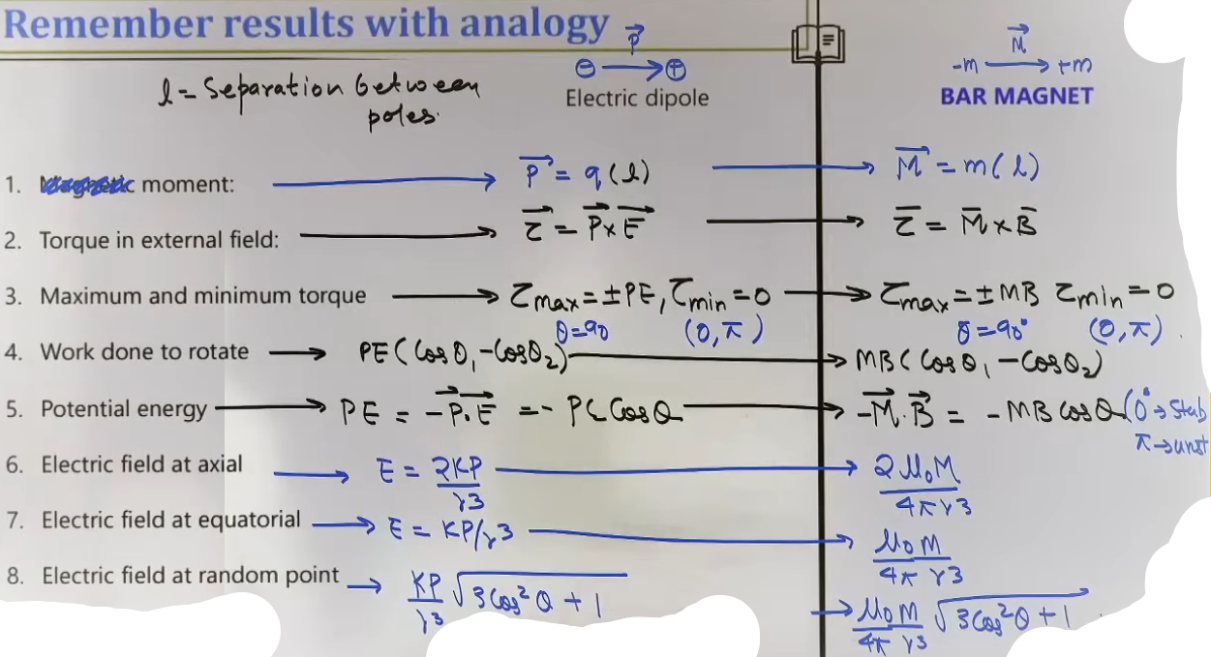
# { k --> μ₀/4π }
# { p --> M }
# { E --> B }

Common Mistakes and Traps
• Monopole Trap: Never assume a single North or South pole exists in a problem; the net flux out of a magnet is always zero.
• Cutting Confusion: Students often think pole strength only changes if you cut "across" the magnet; remember, m ∝ Area, so cutting parallel to the length reduces m.
• Bending Mistake: Using the arc length instead of the straight-line distance (chord) between the two poles for the new magnetic moment.

High-Yield Revision Sheet
• M⃗ Direction: South to North.
• Cutting Rule: M_new = M/n regardless of whether the cut is longitudinal or transverse.
• Force Rule: Force between two point charges is 1/r², but between two dipoles, it is 1/r⁴.
• Magnetic Field at a Distance r:
• Axial: μ₀/4π × 2M/r³.
• Equatorial: μ₀/4π × M/r³.
• SHM Time Period: If a magnet of moment of inertia I oscillates in field B:
T = 2π √(I/MB).

--------------------------------------------------------------------------------

OSCILLATIONS AND TIME PERIOD

These notes cover the vibrational mechanics of magnetic dipoles in external fields, focusing on time period derivations and the behavior of combined magnetic systems, as discussed in the sources.

Core Theory: Time Period of Oscillation
When a magnetic dipole (bar magnet or current loop) is placed in a uniform magnetic field B⃗, it aligns with the field in a state of stable equilibrium (θ = 0°). If it is slightly displaced by a small angle θ and released, it performs Simple Harmonic Motion (SHM).

• Restoring Torque: The external field exerts a torque τ = -MB sin θ. The negative sign indicates the torque acts to restore the dipole to its equilibrium position.
• Small Angle Approximation: For small oscillations, sin θ ≈ θ (in radians). Thus, τ ≈ -Mbθ.

• Equation of Motion: From rotational mechanics, τ = Iα, where I is the Moment of Inertia of the magnet.
- Iα = -MBθ
- α = -(MB/I)θ
• Angular Frequency (ω): Comparing this to the standard SHM equation (α = -ω²θ), we get ω = √(MB/I).

• Final Formula: The time period T is given by:
T = 2π √(I/MB)
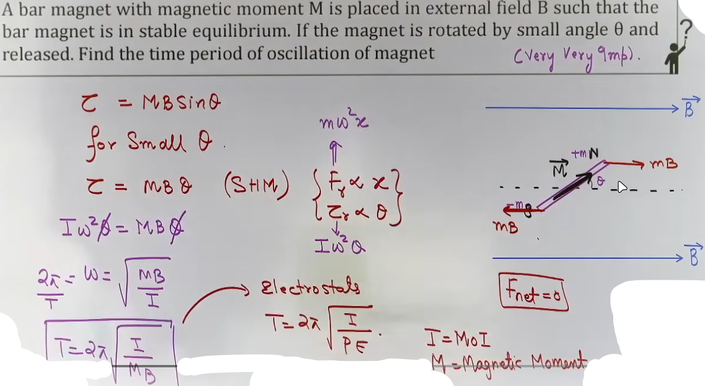
Intuition and Conceptual Understanding
• Mental Model: Imagine the magnetic field lines acting like invisible springs. When you twist the magnet, the "springs" pull it back. Because the magnet has mass (moment of inertia), it overshoots the center, creating an oscillation.
• The SHM Requirement: If the angle θ is large, the motion is oscillatory but not SHM because the torque is proportional to sin θ, not θ.
• Role of Inertia: A heavier or longer magnet (higher I) will oscillate more slowly, while a stronger magnet or field (higher M or B) will pull back harder, resulting in a faster oscillation (smaller T).

Formula Sheet
+----------+-------------------------------------------------+-------------+
| Variable | Definition | Units |
+----------+-------------------------------------------------+-------------+
| T | Time Period of one full oscillation | Seconds (s) |
| I | Moment of Inertia (depends on axis of rotation) | kg·m² |
| M | Magnetic Dipole Moment (NIA or m × L) | A·m² |
| B | External Magnetic Field | Tesla (T) |
+----------+-------------------------------------------------+-------------+

Key Formulas:
• General Time Period: T = 2π √(I/MB)
• Comparison of two magnets in the same field: T₁/T₂ = √(I₁M₂/I₂M₁)
• Comparison of one magnet in two different fields: T₁/T₂ = √(B₂/B₁)

Combination of Magnets (Sum and Difference Positions)
When two magnets are coupled together (placed one on top of the other) and allowed to oscillate, their net properties change.
Case | Arrangement | Net Magnetic Moment (M_net) | Net Moment of Inertia (I_net) | Time Period Formula
Sum Position | Like poles together (N over N, S over S) | M₁ + M₂ | I₁ + I₂ | Tₛ = 2π√{(I₁+I₂)/  [(M₁ + M₂)B]}
Difference Position | Opposite poles together (N over S, S over N) | |M₁ - M₂| | I₁ + I₂ | T_d = 2π√{(I₁+I₂)/  (|M₁ - M₂|B)}

Problem-Solving Framework
Question Type | Identification Clues | Approach / Strategy
Sum & Difference | "Magnets placed with like poles together, then opposite..." | Use the ratio: T_d²/T_s² = (M₁ + M₂)/(M₁ - M₂). This is often used to find the ratio M₁/M₂.
Cutting & Oscillating | "A magnet is cut into two and then oscillated..." | 1. Calculate new M and new I. 2. Plug into T = 2π √(I/MB).
Field Comparison | "Time period changes from T₁ to T₂ in a new location..." | Use T ∝ 1/√B. Often used to compare Earth's magnetic field at different latitudes.

Concept Connections
• Electrostatics: This is perfectly analogous to an electric dipole in an electric field: T = 2π √(I/pE).
• Rotational Dynamics: Problems may require calculating I for a bar magnet (thin rod) about its center: I = 1/12 ML².
• Earth's Magnetism: If a magnet oscillates in a horizontal plane, the B in the formula is specifically Bₕ (the horizontal component of Earth's field).

Common Mistakes and Traps
Mistake | Why Students Make It | Correct Approach / Thinking
Forgetting I units | Mixing grams and centimeters. | Always convert mass to kg and length to meters to get I in kg·m²
Incorrect M_net for Difference | Subtracting I instead of M. | Moment of Inertia (I) always adds (I₁ + I₂) because mass is scalar, but M subtracts vectorially in the difference position.
Mass vs. Moment of Inertia | Using mass (m) in the formula. | The formula requires Moment of Inertia (I), not just mass.

High-Yield Revision Sheet
Must Remember:
• Standard Formula: T = 2π √(I/MB).
• Sum/Difference Ratio: M₁/M₂ = (T_d² + T_s²)/(T_d² - T_s²).
• Stability: Oscillation only occurs when released from near a stable equilibrium (θ = 0°).

Last-Minute Revision Points:
• If T is given as frequency (f), remember f = 1/2π √(MB/I).
• In the difference position, the magnet with the larger magnetic moment determines the direction of the net moment.
--------------------------------------------------------------------------------
EARTH’S MAGNETISM

Core Theory: Geographic and Magnetic Terms
Earth acts as a giant magnetic dipole. To understand its field, we must define specific reference terms:
• Geographic Axis: The straight line passing through the Geographic North and South poles about which the Earth rotates.
• Geographic Meridian: A vertical plane passing through the geographic axis at any given location.
• Magnetic Axis: The straight line passing through the Earth's magnetic poles. This axis is tilted relative to the geographic axis (approximately 11.3°).
• Magnetic Meridian: A vertical plane passing through the magnetic axis. It is the plane in which a freely suspended magnetic needle comes to rest.

• Magnetic Poles:
- Magnetic North (Nₘ): Located near the Geographic North Pole. Magnetic field lines enter the Earth here.
- Magnetic South (Sₘ): Located near the Geographic South Pole. Magnetic field lines emerge from the Earth here.

Elements of Earth's Magnetism
To completely describe the Earth's magnetic field at any point, three parameters (elements) are required:

A. Magnetic Declination (θ or α)
• Definition: The angle between the Geographic Meridian and the Magnetic Meridian at a given place.
• Significance: A compass points toward Magnetic North; the declination tells you how much you must correct this reading to find True (Geographic) North.

B. Angle of Dip or Inclination (δ)
• Definition: The angle that the total magnetic field of the Earth (B⃗ₑ) makes with the horizontal direction in the magnetic meridian.
• Hemisphere Variations:
- Northern Hemisphere: The North pole of a needle dips downward (Positive Dip).
- Southern Hemisphere: The North pole of a needle points upward (Angle of Inclination).

• Critical Values:
- At the Magnetic Equator: δ = 0° (Field is purely horizontal).
- At the Magnetic Poles: δ = 90° (Field is purely vertical).

C. Horizontal Component of Earth's Field (Bₕ)
• Definition: The component of the Earth's total magnetic field in the horizontal direction.

Intuition and Conceptual Understanding
• Mental Model: Imagine a giant bar magnet buried deep inside the Earth. However, the "South" pole of this imaginary magnet is near the Geographic North, which is why it attracts the North pole of your compass.
• Visualizing Dip: If you are at the North Pole, the field lines are going straight into the ground. Your needle wants to point straight down. At the Equator, field lines are parallel to the surface, so the needle stays horizontal.
• Dip Circle: A dip circle is used to measure δ. It must be placed exactly in the Magnetic Meridian to read the true dip. If placed in any other plane, it reads an apparent dip.

Formula Sheet
+--------------------------+-------------------+-----------------------------+
| Parameter | Formula | Notes |
+--------------------------+-------------------+-----------------------------+
| Horizontal Component | Bₕ = Bₑ cos δ | Bₑ = Total field |
| Vertical Component | Bᵥ = Bₑ sin δ | |
| Total Field Magnitude | Bₑ = √(Bₕ² + Bᵥ²) | Standard vector sum |
| Relation between Bₕ, Bᵥ | tan δ = Bᵥ/Bₕ | Fundamental for dip problems|
+--------------------------+-------------------+-----------------------------+

Problem-Solving Framework
Question Type | Identification Clues | Approach / Strategy
Finding Total Field | Given Bₕ and Dip (δ) | Use Bₑ = Bₕ/cos δ
Apparent Dip | "Dip circle is at an angle β to the meridian" | 1. Horizontal component becomes Bₕ cosβ  2. New tan δ' = Bᵥ / (Bₕ cos β) = tan δ_true / cos β
Location Tracking | "Where is the horizontal component zero?" | At the Magnetic Poles, where the field is purely vertical (δ = 90°).

JEE Advanced Insights
• Relationship between Latitude and Dip: While not a simple linear 1:1, Dip increases as you move from the equator toward the poles.
• The "True North" Trap: Remember that the geographic meridian is the one that stays constant for a location; the magnetic meridian can change slightly over long periods due to changes in the Earth's core.
• Neutral Points: When placing a bar magnet on a table, the net field is the vector sum of the magnet's field and Bₕ only (since the magnet is horizontal).

Common Mistakes and Traps
Mistake | Why Students Make It | Correct Approach / Thinking
Using Bₑ for Torque | Forgetting Bᵥ doesn't affect horizontal needles. | If a compass oscillates in a horizontal plane, only Bₕ provides the restoring torque.
Confusing Declination/Dip | Mixing up the names. | Declination = Horizontal error (θ); Dip = Vertical tilt (δ).
Bₕ at Poles | Thinking Bₕ is max at poles. | Bₕ is zero at the poles because the field is entirely vertical.

High-Yield Revision Sheet
• At Equator: δ = 0°, Bᵥ = 0, Bₕ = Bₑ.
• At Poles: δ = 90°, Bₕ = 0, Bᵥ = Bₑ.
• India's Location: India is in the Northern Hemisphere; therefore, the angle of dip is positive (needle points down).
• Tangent Law: Bᵥ/Bₕ = tan δ is the most frequently used relationship in JEE Main.

--------------------------------------------------------------------------------

ATOMIC MAGNETISM AND MATERIAL PROPERTIES

Magnetism of a Revolving Electron for hydrogen or hydrogen like species only
In an atom, an electron revolving in an orbit acts as a tiny current loop. Because the electron has charge and is in motion, it generates a magnetic field and possesses a magnetic dipole moment.

• Current (I): Since I = q/T, for an electron, I = e/T = ef, where f is the frequency of revolution.
• Magnetic Moment (M): Defined as M = IA. For a circular orbit, M = I(πr²).
• Bohr Magneton: This is the minimum magnetic moment of an electron, occurring in the first Bohr orbit.
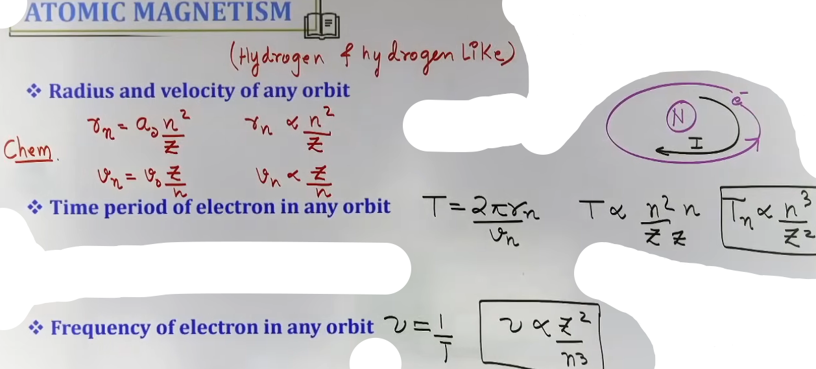
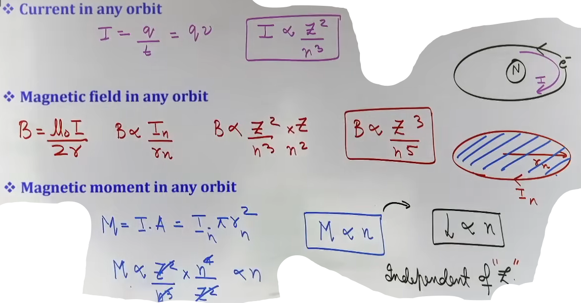
Formula Sheet: Proportionality in Bohr Orbits
+------------------------+-----------------------+-----------------------------+
| Property |Proportionality Formula| JEE Significance |
+------------------------+-----------------------+-----------------------------+
| Radius (r) | r ∝ n²/Z |Foundation for M calculation |
| Velocity (v) | v ∝ Z/n | Used to find current I |
| Time Period (T) | T ∝ n³/Z² | T = 2πr/v |
| Frequency (f) | f ∝ Z²/n³ | f = 1/T |
| Current (I) | I ∝ Z²/n³ | I = ef |
| Magnetic Moment (M) | M ∝ n | Independent of Z; M = IA, |
|Magnetic Field(B_center)| B ∝ Z³/n⁵ | B = μ₀I/2r |
+------------------------+-----------------------+-----------------------------+
Gyromagnetic Ratio
• Definition: The ratio of the magnetic dipole moment (M⃗) to the angular momentum (L⃗) of a revolving or spinning charged particle.
• Formula: M/L = q/2m.
• For an electron: M/L = e/2mₑ.
• Vector Form: M⃗ = -(e/2mₑ)L⃗. The negative sign indicates that for an electron, the magnetic moment and angular momentum are in opposite directions because the charge is negative.
• Universality: This ratio is constant for all orbits of an electron in an atom.
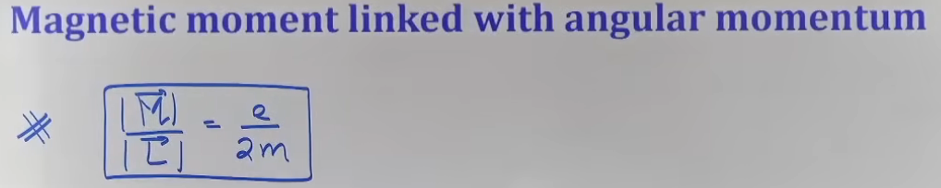
Key Parameters of Magnetic Materials
Before classifying materials, you must understand the quantities that measure how they respond to fields:

• Magnetic Intensity (H): Also called the Magnetizing Field. It represents the external field (usually from a solenoid) used to magnetize a material.
B₀ = μ₀(H)
- For a solenoid, H = nI. , { n --> number of turns per unit length }
- Unit : Ampere/meter

• Intensity of Magnetization (I or M): When a magnetic material is placed in magnetising field then the magnetic moment induced per unit volume of the material is known as intensity of magnetisation.
I = M_net/V
- It measures how strongly a material has become a magnet.
- Unit : Ampere/meter

• Magnetic Susceptibility (χ): Measures how easily a material can be magnetized.
χ = I/H
- Higher χ ⇒ More easy to magnetise
- Unit : unitless

• Relative Permeability (μᵣ): The ratio of the magnetic field in the material (B) to the field in a vacuum (B₀).
μᵣ = B/B₀ = Bₘ/H.
dia --> μᵣ < 1
para --> μᵣ > 1
ferro --> μᵣ >>>1
• Crucial Relation: μᵣ = 1 + χ.
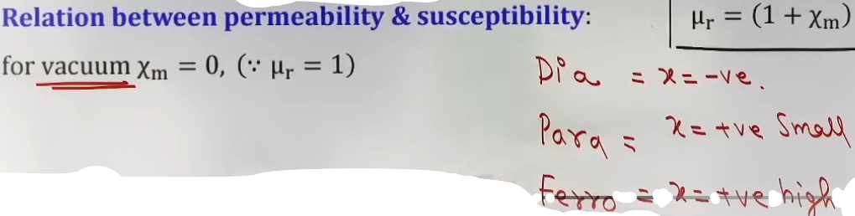
# magnetic intensity --> bahari (external) field kitni takatwar thi
# intensity of magnetization --> kitna tagra magnet bana
# magnetic susceptibility --> kitni aasani se magnet banega

Classification of Materials
Property | Diamagnetic | Paramagnetic | Ferromagnetic
Origin | Orbital motion of electrons. | Spin of unpaired electrons. | Formation of Domains.
Behavior in Field | Weakly repelled. | Weakly attracted. | Strongly attracted.
Effect on Field Lines | Field lines are expelled. | Field lines are concentrated. | Field lines are highly concentrated.
Susceptibility (χ) | Small and Negative. | Small and Positive. | Large and Positive.
Permeability (μᵣ) | μᵣ < 1. | μᵣ > 1. | μᵣ >> 1.
Magnetic moment of single atom | Atoms do not have any permanent magnetic moment | Atoms have permanent magnetic moment which are randomly oriented. (i.e. in absence of external magnetic field the magnetic moment of whole material is zero) | Atoms have permanent magnetic moment which are organised in domains.
Temperature Effect | Independent of T. | χ ∝ 1/T (Curie's Law). | Complex; becomes Para above T_C.

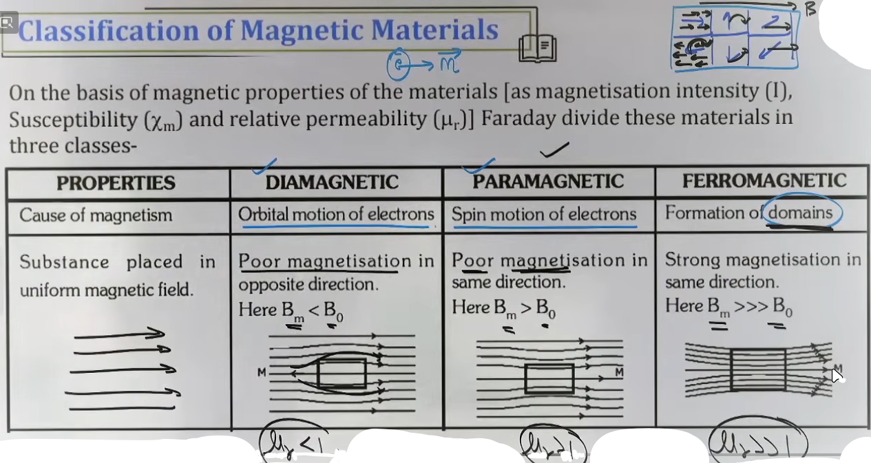
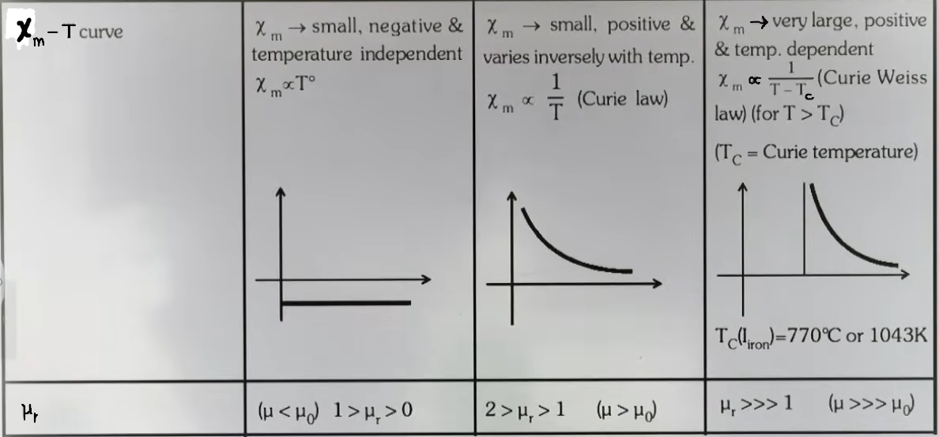
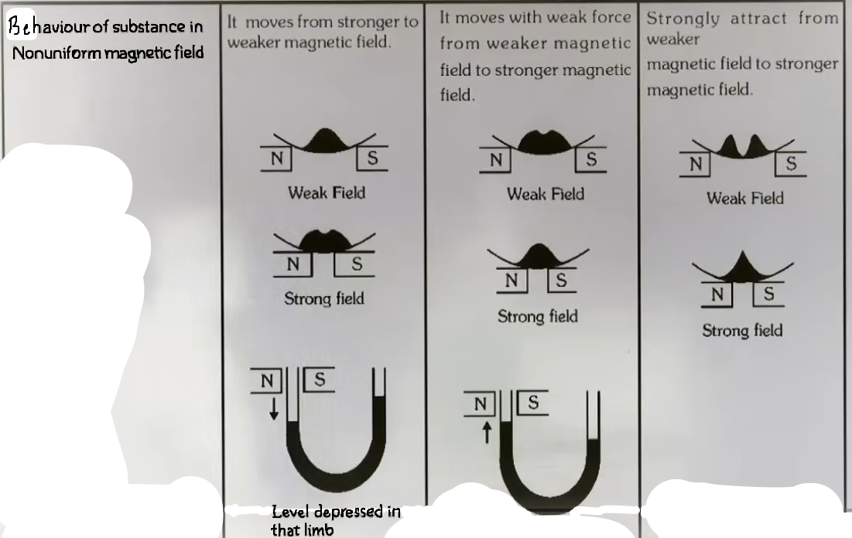
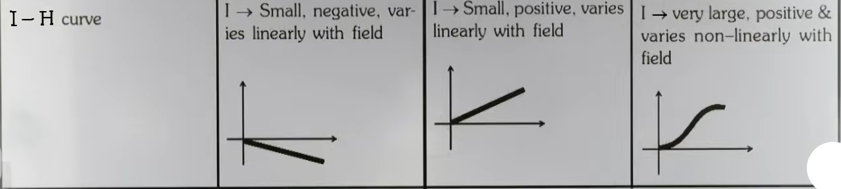
Curie’s Law and Curie Temperature
• Curie’s Law (Paramagnetics): The magnetic susceptibility of a paramagnetic material is inversely proportional to its absolute temperature:
χ = C/T
• Intuition: Increasing temperature increases thermal agitation, which disrupts the alignment of atomic dipoles.
• Curie-Weiss Law (Ferromagnetics): Above a specific temperature called the Curie Temperature (T_C), a ferromagnetic material loses its domain structure and behaves as a paramagnetic material.
χ = C/(T - T_C) (for T > T_C)

Hysteresis
Hysteresis is the phenomenon where the magnetic induction (B) lags behind the magnetizing field (H) in a ferromagnetic material.

The Hysteresis Loop (I-H or B-H curve)-
• Saturation: As H increases, I reaches a maximum where all domains are aligned.
• Retentivity (Remanence): When H is reduced to zero, the material still retains some magnetization (I ≠ 0). This value is the retentivity. { y-axis intercept }
• Coercivity: The value of the reverse magnetic field (negative H) required to reduce the residual magnetization to zero. { x-axis intercept }
• Area of the Loop: The area enclosed by the hysteresis loop represents the energy loss per unit volume per cycle of magnetization.
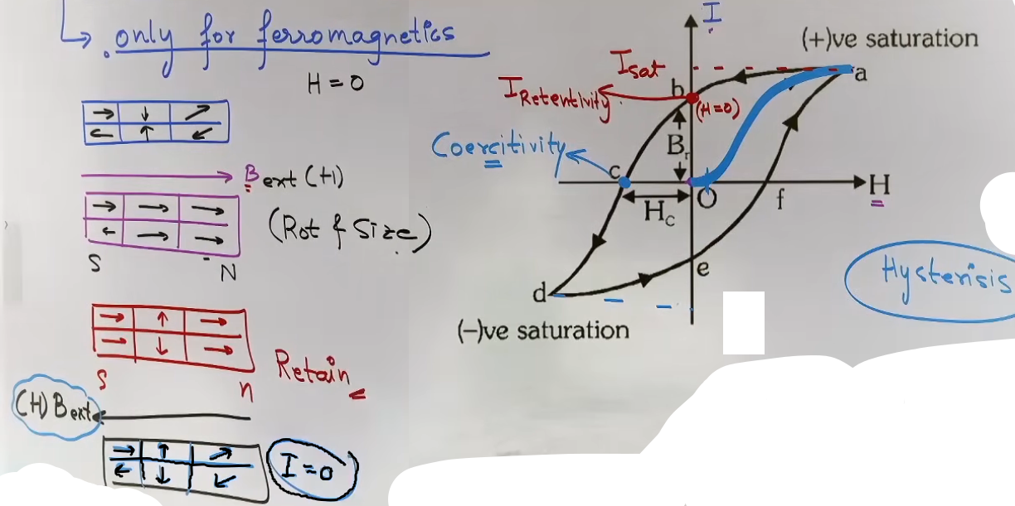
Applications: Soft Iron vs. Steel
JEE frequently asks to compare these based on their hysteresis properties.
+-----------------+----------------------------+-------------------------------+
| Property | Soft Iron | Steel |
+-----------------+----------------------------+-------------------------------+
| Retentivity | High | Low/Moderate |
| Coercivity | Low (Easily demagnetized) |High(Difficult to demagnetized)|
| Hysteresis Loss | Low (Thin loop) | High (Wide loop) |
| Permeability | High | Lower than Soft Iron |
| Best Used For |Electromagnets,Transformers,| Permanent Magnets. |
| |Core of Solenoids. | |
+-----------------+----------------------------+-------------------------------+

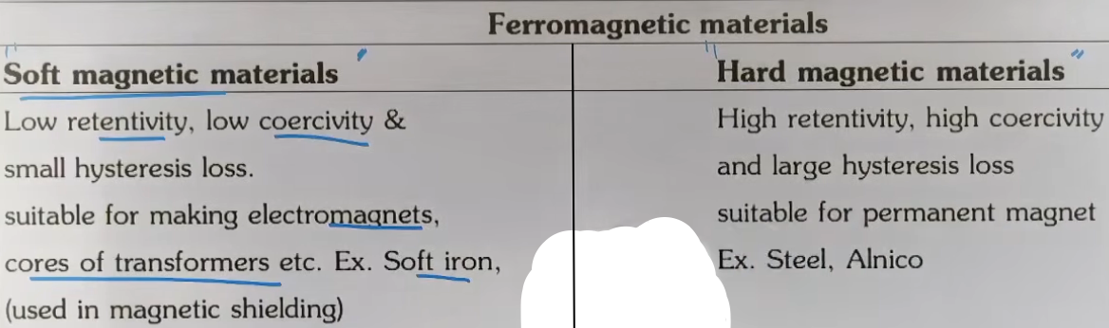
Problem-Solving Framework
Question Type | Identification Clues | Approach / Strategy
Atomic Scaling | "Ratio of M in 2nd vs 1st orbit" | Use M ∝ n. The ratio is 2:1.
Superconductor | Mention of "Perfect Diamagnet" | Set χ = -1 and μᵣ = 0. Field lines cannot enter.
Temperature Change | "Susceptibility at T₁ is χ₁, find at T₂" | Use χ₁ T₁ = χ₂ T₂ (Curie's Law).
Domain Logic | "Ferro material becomes Para" | Material has been heated above T_C.

JEE Advanced Insights
• Magnetism vs. Electrostatics: Magnetic monopoles do not exist (M = mL is an approximation for calculations), but B_axial and B_equatorial follow the same 1/r³ law as electric dipoles.
• Force between Dipoles: For two small dipoles, the force is proportional to 1/r⁴, unlike the 1/r² for charges.
• Hysteresis Energy Loss: Total energy lost in N cycles = N × Area of Loop × Volume.

High-Yield Revision Sheet
Must Remember
• Electron M: M = evr/2 = eL/2m.
• Gyromagnetic Ratio: Constant for an electron = 8.8 × 10¹⁰ C/kg.
• Relation: μᵣ = 1 + χ.
• χ for Dia: Negative; χ for Para: Positive; χ for Ferro: Very Large.
• Curie Temp: Transition point between Ferro and Para behavior.

Common Mistakes and Traps
• Confusing M ∝ n: Students often think M depends on Z in Bohr orbits; it doesn't. It depends only on n.
• χ for Diamagnets: Students forget that χ for diamagnets is independent of temperature.
• Hysteresis Loop: Assuming the loop is for all materials. It is only for Ferromagnetics.
• Coercivity Units: Coercivity is measured in A/m (same as H).

